***EXPERIMENT # 3***

***Observe the working principle of four stroke petrol engine.***

* **Introduction:**
* **Definition:**

“A four stroke engine is also called an internal combustion or spark ignition engine in which four strokes required to complete one cycle.”

A four-stroke (also four-cycle) engine is an [internal combustion](https://en.wikipedia.org/wiki/Internal_combustion) (IC) engine in which the [piston](https://en.wikipedia.org/wiki/Piston) completes four separate strokes while turning the crankshaft. A stroke refers to the full travel of the piston along the cylinder, in either direction.

* **Process:**

1. Intake.
2. Compression.
3. Power/ignition
4. Exhaust

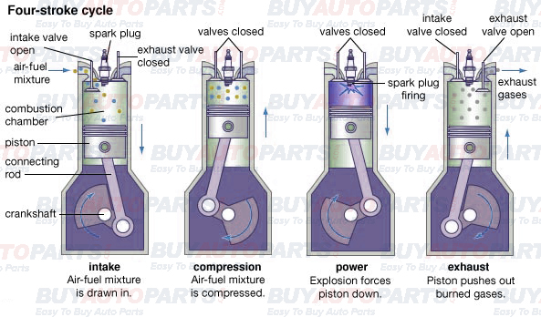

* **Intake:**

It is also known as induction or suction. This stroke of the piston begins at top dead center (T.D.C.) and ends at bottom dead center (B.D.C.).In intake process pressure become to decrease and volume start increased.

In this stroke the intake valve must be in the open position while the piston pulls an air-fuel mixture into the cylinder by producing vacuum pressure into the cylinder through its downward motion. The piston is moving down as air is being sucked in by the downward motion against the piston .The intake process is shown in diagram.

* **Compression:**

This stroke begins at B.D.C, or just at the end of the suction stroke, and ends at T.D.C. In compression process volume decreased and pressure increased.

In this stroke the piston compresses the air-fuel mixture in preparation for ignition during the power stroke (below). Both the intake and exhaust valves are closed during this stage .The compression process shown in diagram.

* **Power:**

It is also known as combustion. This is the start of the second revolution of the four stroke cycle. At this point the crankshaft has completed a full 360 degree revolution.

While the piston is at T.D.C. (the end of the compression stroke) the compressed air-fuel mixture is ignited by a [spark plug](https://en.wikipedia.org/wiki/Spark_plug) (in a gasoline engine) or by heat generated by high compression (diesel engines), forcefully returning the piston to B.D.C.

During ignition process volume remains constant and pressure also remain constant .This stroke produces mechanical work from the engine to turn the crankshaft .The power process is shown in diagram. In power process volume is increased and pressure is decreased.

* **Exhaust:**

  It is also known as outlet. During the *exhaust* stroke, the piston, once again, returns from B.D.C. to T.D.C. while the exhaust valve is open. This action expels the spent air-fuel mixture through the exhaust valve .Pressure is increased and volume is decreased.

* 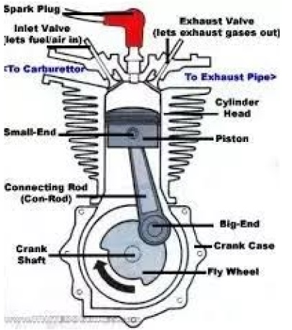**Diagram:**
  1. **Crank Shaft.**
  2. **Connecting Rod.**
  3. **Piston.**
  4. **Inlet Channel.**
  5. **Outlet Channel.**
  6. **Spark Plug.**
  7. **Carburetor.**
  8. **Throttle Valve.**
  9. **Cam shaft**
* **Crank Shaft:**

The crankshaft design also establishes the length of the piston stroke because the radial offset of each throw is equal to half the stroke imparted to the piston. The ratio of the piston stroke to the cylinder bore diameter is an important design consideration.

* **Connecting Rod:**

A **connecting rod**, also called a **con rod**, is the part of a [piston engine](https://en.wikipedia.org/wiki/Reciprocating_engine) which connects the [piston](https://en.wikipedia.org/wiki/Piston) to the [crankshaft](https://en.wikipedia.org/wiki/Crankshaft). Together with the [crank](https://en.wikipedia.org/wiki/Crank_(mechanism)), the connecting rod converts the [reciprocating motion](https://en.wikipedia.org/wiki/Reciprocating_motion) of the piston into the rotation of the crankshaft. The connecting rod is required to transmit the compressive and tensile forces from the piston, and rotate at both ends.

* **Piston:**

As the t piston rises on compression, its underside pulls a partial vacuum in the crankcase. An intake port of some kind (cylinder wall port, reed valve or rotary disc valve) opens, allowing air to rush into the crankcase through a carburetor.

* **Inlet Channel:**

The inlet port is connects to transfer passage leading to the fully enclosed crank case. A spring loaded inlet valve admits air into the crank case on the upward compression stroke of the piston. Air trapped into the crank case is compressed by the descent of the piston of the power stroke.

* **Outlet valve:**

The [outlet valve](https://www.sciencedirect.com/topics/engineering/outlet-valve) is given a lead in opening before the piston reaches bottom dead center on the power stroke .Thus the [burnt gases](https://www.sciencedirect.com/topics/engineering/burnt-gas) are already leaving the cylinder under their own pressure as the piston begins its exhaust stroke. As a result, the engine expends less energy on expelling the exhaust gases than would otherwise be the case.

The outlet valve is also provided with a lag in closing after the piston reaches top dead center and begins the induction stroke .This better [scavenges](https://www.sciencedirect.com/topics/engineering/scavenge) the [combustion chamber](https://www.sciencedirect.com/topics/engineering/combustion-chamber) of exhaust gases and lowers [cylinder pressure](https://www.sciencedirect.com/topics/engineering/cylinder-pressure) to facilitate flow of the incoming air and petrol mixture

* **Spark Plug:**

In Dual Spark ignition engine has two Spark plugs located at opposite ends of the combustion chamber and hence fast and efficient combustion is obtains.

The benefits of this combustion process can be felt in terms of better fuel efficiency and lower emissions. Dual Sparkplugs used for faster and better combustion.

* **Carburetor:**

Fuel reaches the combustion chamber with the help of fuel pump. ... This mixture of air and fuel is carburetor. Hence a petrol engine is also known as spark ignition engine, since a spark is used to burn a mixture of air and petrol (or gasoline).

* **Throttle Valve:**

A throttle is the mechanism by which [fluid flow](https://en.wikipedia.org/wiki/Fluid_flow) is managed by constriction or obstruction .An [engine](https://en.wikipedia.org/wiki/Engine)'s power can be increased or decreased by the restriction of inlet gases (by the use of a throttle), but usually decreased. The term *throttle* has come to refer, informally, to any mechanism by which the power or speed of an engine is regulated, such as a car's accelerator pedal.

What is often termed a *throttle* (in an aviation context) is also called a [thrust lever](https://en.wikipedia.org/wiki/Thrust_lever), particularly for [jet engine](https://en.wikipedia.org/wiki/Jet_engine) powered aircraft. For a [steam locomotive](https://en.wikipedia.org/wiki/Steam_locomotive), the valve which controls the steam is known as the regulator.

* **Cam shaft:**

This is very magic thing .At starting cam shaft touching with inlet valve. When inlet process is happened cam shaft push the inlet valve and it is opened .when crank shaft complete one cycle it complete half cycle .during the exhaust process it opened the exhaust valve.

* **Applications:**

Four stroke petrol engine commonly used in following:

* Petrol cars.
* Motor bikes.
* Scooters.
* Small propeller aircrafts.
* Small motor powered boats.
* Auto Rickshaws
* Water sprays system.

The four stroke petrol engine has a wide application since the higher value of the low end punch capabilities of the engine.

* **Difference:**

|  |  |
| --- | --- |
| **Four Stroke Petrol Engine**   * The spark plugs fire only once every other revolutions and power is produced every 4-strokes of the piston. * These engines also do not require pre-mixing of fuel and oil, as they have a separate compartment for the oil. * In a 4-stroke engine, the piston completes 2-strokes during each revolution: one compression stroke and one exhaust stroke, each being followed by a return stroke. * More thermal efficiency. * High working temperature. * More friction loss * More capital cost * Less power to weight ratio | **Two Stroke Petrol Engine:**   * The spark plugs fire once every single revolutions and power is produced once every 2-strokes of the piston. * Two-stroke engines require the oil to be pre-mixed in with the fuel. * In a 2-stroke engine, the entire combustion cycle is completed with just one piston stroke: a compression stroke followed by the explosion of the compressed fuel. During the return stroke, the exhaust is let out and a fresh fuel mixture enters the cylinder. * Less thermal efficiency. * Low working temperature * Low friction loss * Less capital cost * More power to weight ratio |

* **Conclusion:.**

We conclude that four stroke is efficient as compared to two stroke engine .We learn that how we use the four stroke engine.